Name: Arjun Patel

FRN-13J1124/**006**

Test 2

Que. 1)

*//calculate electricity bill*

*/\**

*1-50 units --> 30 rs/unit*

*51-150 units --> 40 rs/unit*

*>151 units --> 50 rs/unit*

*\*/*

*#include*<stdio.h>

int main(){

    float unitCount, perUnitCharge, billAmount;

    printf("Enter unit that is used by user\n");

    scanf("%f", *&*unitCount);

*if*(unitCount*>=*1 *&&* unitCount*<=*50){

        perUnitCharge *=* 30;

    }

*else* *if*(unitCount*>=* 51 *&&* unitCount*<=*150){

        perUnitCharge *=* 40;

    }

*else* *if*(unitCount*>*150){

        perUnitCharge *=* 50;

    }

*else*{

        printf("Invalid input\n");

*return* 0;

    }

    printf("Total Amount to be paid is %.2f", perUnitCharge *\** unitCount);

*return* 0;

}

Output:

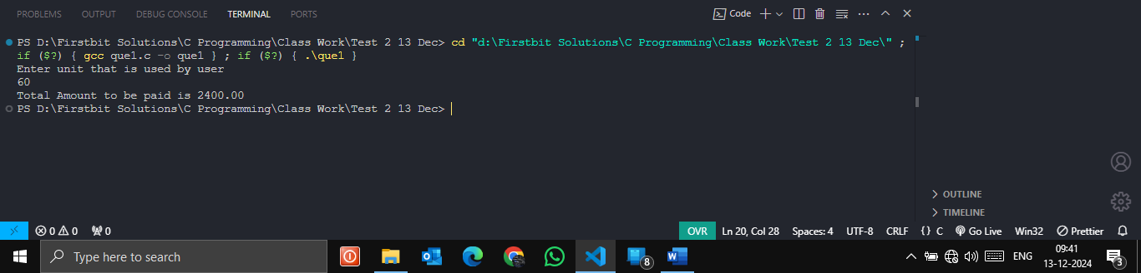

**Que 2):**

*//check num is +ve, -ve, or zero*

*#include*<stdio.h>

int main(){

    int num;

    printf("Enter Num\n");

    scanf("%d", *&*num);

*if* (num*<*0)

    {

        printf("%d is negative number\n", num);

    }

*else* *if*(num*>*0){

        printf("%d is positive number\n", num);

    }

*else* *if*(num*==*0) {

        printf("%d is neutral\n",num);

    }

*else* printf("Invalid Input!!!");

*return* 0;

}

**Output:**

